Marshall Child Development Center
May Newsletter 2023
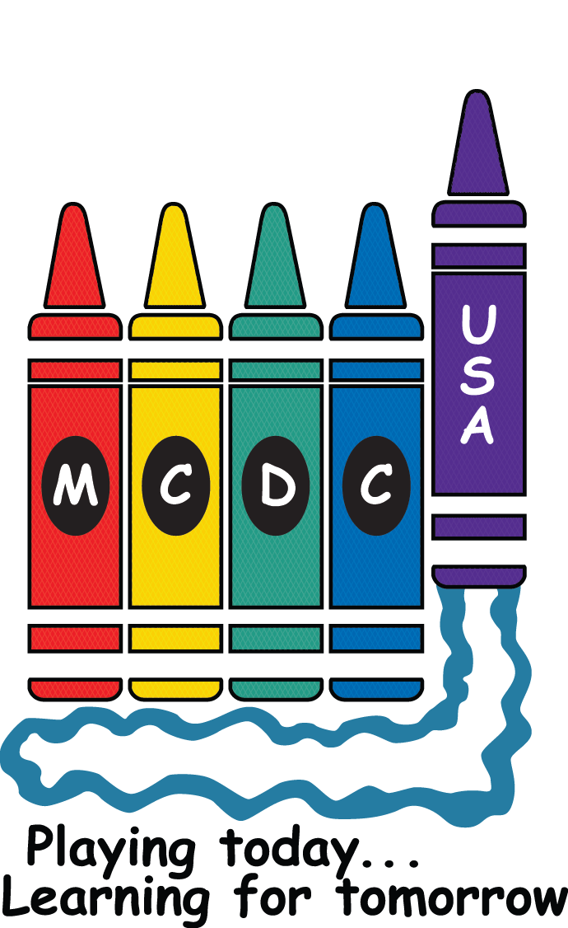

From the Board of Directors…!
Dear MCDC Parents,
It’s time to lift UP our staff and show them our appreciation! MCDC Staff Appreciation Week will be held the week of May 15th – 19th. This is an annual tradition at MCDC, and it is important that we let the staff know how much their efforts mean to us, as parents, since they take such tender care of our precious children every day! This event is made possible by parent volunteers and donations, so please help us build them UP.
This year we are treating the staff to a catered lunch during their scheduled lunch breaks on Wednesday May 17th. This is when we will pass out their memory books (details below) and gift cards.
How can you help?
- Give UP a (voluntary) donation of at least $20 per child to fund the lunch and a gift card for each staff member. More generous donations will be greatly appreciated! Staff Appreciation Week is funded exclusively through donations and not supplemented by MCDC operational funds. You may make your donation through Pay Pal marshallchilddevelopmentcenter@gmail.com or turn in a check to the front office.
- Bake UP some treats for the staff on Monday (5/15) and Thursday (5/18). Some ideas for treats: breakfast casseroles, muffins, bagels, sandwiches, chips/dip, drinks, sweets, crock-pot meal, etc. The treat signup sheet is posted at:
https://www.signupgenius.com/go/10C0949A8AD28ABFBC07-staff
- Build UP a memory book containing art/pictures collected for that staff member. Help by having your child provide artwork and/or photos for the staff member(s) whom they wish to honor by Monday 5/15 to the marked folders in the lobby. More details below!
- Gather UP to help. We really need help assembling the memory books. Sign up here:
https://www.signupgenius.com/go/10C0949A8AD28ABFBC07-memory
Please free UP some of your time to help us make this a week to acknowledge our staff in these special ways.
Want to get to know the teachers and staff better? Need ideas for thank you gifts? Please, check out the “Meet Our Staff” sheets posted in each classroom door 😊
Feel free to contact Natalie Aponte-Mendez and Kara Ayala at mcdcboardofdirectors@gmail.com with any questions.

*******Memory Books for Staff Members
Each staff member will be presented with a memory book containing the art/pictures collected for that staff member. Please have your child provide artwork for the teachers and staff members whom they wish to honor. You may include photos, too. Since the artwork is placed in a keepsake notebook for each staff member, it is important that the artwork DOES NOT EXCEED 8 1/2" X 11". (construction paper will not fit) Please write the child's entire name on the front and the staff member's entire name on each page. This is very important to make sure your page goes to the correct staff member. Don't forget the director, assistant director, cook, floaters and substitutes! Please see the list of staff names at the end of this email to ensure you do not leave anyone out. Please have the artwork placed in the marked folders at the lobby table by close of business on Monday 5/16. Examples of previous years memory books will be available to view for ideas.
Our Staff:
Infant A: Bailey Hammons & Melissa Atchley
Infant B: Janice Parker & Connie Boyd
Infant Floater: Cassandra Woods
Creeper A: Kristin Bliss & Freda Lang
Creeper B: Dawn McClure & Lyric Hughes
Creeper Floater: Elizabeth Janousek
Toddler A: Erica Franklin & Terriale Gilbert (sub)
Toddler B: Catie Holeman & Wendy Smith
Toddler Floater: Mary Garner
Explorer A: Bryanna Williams
Explorer B: Cassidy Thomas & Lisa Bradford
Explorer Floater: Latisa Dickens
Preschool C: Betsy Sikes & Sybil Greenwood
Preschool B: Melissa Kellar & Sandra Clark
Preschool A: Debbie Noble & Aida Royster
Preschool Floater: Jamie Lee Saint
Substitutes: Kari Kaparos, Olivia Marty, Iris Martinez, Courtney Cree, Kayla Bradford, Jennifer Brooks, Lori Chapman (new), Brooke Isom, Misty Holloway
Director: Kelli Wright
Incoming Director: Michelle Featherston
Assistant Director: Cecilia Finn
Incoming Assistant Director: Rhonda Chambliss
Administrative Assistant: Melissa Boylen
Cook: Tina Bartlebaugh
Custodian: Derrick Byrd

From the Director….!

We are looking forward to having Spoiled Rotten Photography here this week for Campus Candids!

Schedule is below. You may dress your child or bring in one outfit and we will change them before their photo. Any special instructions need to be clearly written on a note with your child’s outfit. We start with the younger children and work our way up to the older children. Weather permitting these photos do take place outside. Please let me know if you have any questions!

Wednesday May 10th:
Infant A
Toddler A
Preschool B

Thursday May 11th:
Infant B
Toddler B
Explorer A
Preschool A

Friday May 12th:
Creeper A
Creeper B
Explorer B
Preschool C

Our Mother’s Day Store will be taking place the morning of May 10th. Preschool children will have the opportunity to shop for gifts ($2 each) for their mothers. Please look for envelopes in your child’s classroom.

Please join us on May 12th from 7am-8:30am for Muffins with Mom. Grab a muffin on the go or stay have breakfast with us.

I can’t believe it is already time for our graduation, but it is right around the corner! Preschool A Graduation will take place on Moy 18th at 5:45pm in the Activities Building 4316 on Digney Road. Friends and family are welcome! Please let me know if you will have any guests attending that do not have access to the arsenal.

I would like to thank everyone for all your kind words and well wishes as I finish out my last few weeks at MCDC. I will never forget your kindness and support. I will miss everyone tremendously, but I am confident that Michelle and Rhonda will continue the wonderful program we have built and MCDC will continue to provide the best care to our children and families.

“How lucky I am to have something that makes saying good-bye so hard.”
Winnie the Pooh

Kelli Wright, Director

*Please make note of calendar change. Anniversary Picnic has been moved to June 2nd.
Upcoming Events:

May 3rd-11th-= Tina out
May 10th= Mother’s Day Store (preschool; gifts $2 each)
May 10th-12th= Campus Candids
May 12th= Muffins for Moms 7:00am-8:30am
May 12th= Board Meeting 9am
May 15th-19th= Staff Appreciation Week
May 18th= Preschool A Graduation 5:45pm Bldg 4316 (Activities Building)
May 19th= Kelli and Cecilia’s last day
May 22nd-26th= Derrick Out
May 25th= Staff Meeting 5;45pm
May 26th= Board Meeting 9am
May 29th= Center Closed for Memorial Day

Coming Up in June:

Anniversary Picnic June 2nd 5:30pm-7:00pm
Father’s Day Store June 14th
Donuts for Dad June 16th
Center Closed Juneteenth June 19th
Fourth of July Parade June 29th
Staff Meeting June 29th

Hello from (Infant A)
Hello, Parents of Infant A! Spring has Sprung! The bees are a buzzin’, the flowers are bloomin’, and our infants’ babies are growin’. Our infants are of various months and the older ones are learning how to sit up unassisted and are trying solid foods. Our younger infants are mastering head control, rolling over, and tummy time.
We are looking forward to many fun times this month and will be working on something special for Mother’s Day. As always, if you ever have any questions or concerns, feel free to reach out to us via telephone or brightwheel. Please be sure to have several weather appropriate spare outfits in your child’s cubby for spit ups and blow outs.

The Beautiful Babies (Infant B)
Hello, here are a few ideas to show children ways to help them develop vocabulary and language skills.
A young infant might:
- Calm down when you sing a favorite lullaby or talk to him in a quiet, reassuring voice.
- Turn her head towards you and smile when you speak to her.
- Make sounds directed to you, listen intently when you imitate the sounds, then repeat the sounds again and again.
- Lift his arms up when you come to his crib and ask, “Do you want to get up?”
- Make sounds like “Ma-ma and Da-da.”
We hope all our families have a safe and happy spring.

Farmtastic (Creeper A)
Hello from Creeper A! Happy May! We cannot believe how quickly this year is going by or how quickly these babies are growing. For the month of May, we will be studying the sky and what we see up there. This lesson should include some outside exploration, so please make sure your child has weather appropriate outfits either on or to be changed into.

Up Coming Events:
We have several big dates coming up in May.
- May 10th-12th: Campus Candid’s
- May 12th: Muffins for Mom
- May 15th-19th: Staff Appreciation Week
- May 19th-Director and Assistant Director’s last day
- May 29th-Center Closed for Memorial Day

Welcome to Creeper A
- We have a few new families to welcome to our room! We are so excited to have you and to love on your little one.

Birthdays
- We do not have any birthdays to celebrate this month.

What we will be Learning
- We will be playing fun games and exercises with the children this month to help strengthen both gross and fine motor skills.

Reminders
- If you have any questions about your child, please contact us directly on brightwheel-if it’s important or time sensitive, please call.
- Make sure your child has extra clothes that are the correct size and season.

The Little Owls (Creeper B)
Hello parents! We are looking forward to the warmer weather so we can go outside to play more. Our playground is being cleaned we will be able to use the slide, push pull toys, and play with the balls. We are looking forward to it!
The month of May we will be talking about “Friends.” We will talk about who our friends are, how we share with our friends, play with our friends, and help our friends. If anyone has a book about friends they would like to share with the class, feel free to bring it in!
Reminders:
- Please make sure to apply sunscreen to your child before coming to school.
- Please make sure your child has sunscreen we can use while at school for the afternoon.
- Please check your child’s cubby for age appropriate and weather appropriate clothes!
- Memorial Day May 29th-Center Closed

The Busy Bees (Toddler A)
Happy May everyone! We are so excited about this month. We will be discovering and identifying all kinds of pets that people own! I know the kids are going to love it! We will be focusing on dogs, cats, birds, hamsters and lizards. Bring a picture of your pet is you have one!

Reminders:
Sunscreen applied every morning before school Make sure that weather appropriate clothes are available Tennis and socks are the best for our outdoor playground!

Dates to remember:
May 12 Mother’s Day special snack
May 15th-19th Staff Appreciation Week
May 29 center closed for Memorial Day

Never hesitate to message on brightwheel or talk to me about any questions or concerns Thank you!

Clever Foxes (Toddler B)
Toddler B presents Camp May! April was amazing, we learned so much about the weather and had some great hands-on experience! Now we are ready to jump into a marvelous May, featuring outdoor play and STEAM inspired activities!

What to remember:
- You apply your child’s first coat of sunscreen in the morning, we will do the second after snack
- Be sure to switch out your extra winter clothes with warm weather appropriate options
- Play and learning using hands-on tactics can be messy. We will change clothes if needed. Remember, a messy toddler = a growing toddler!
In May, we will be focusing on counting, parallel and cooperative play techniques, sensory art, and gross and fine motor skills. Much of this will be done outdoors, though on our indoor days we will focus on imitating camping experiences that engage us in nature by using new physical and mental skills.
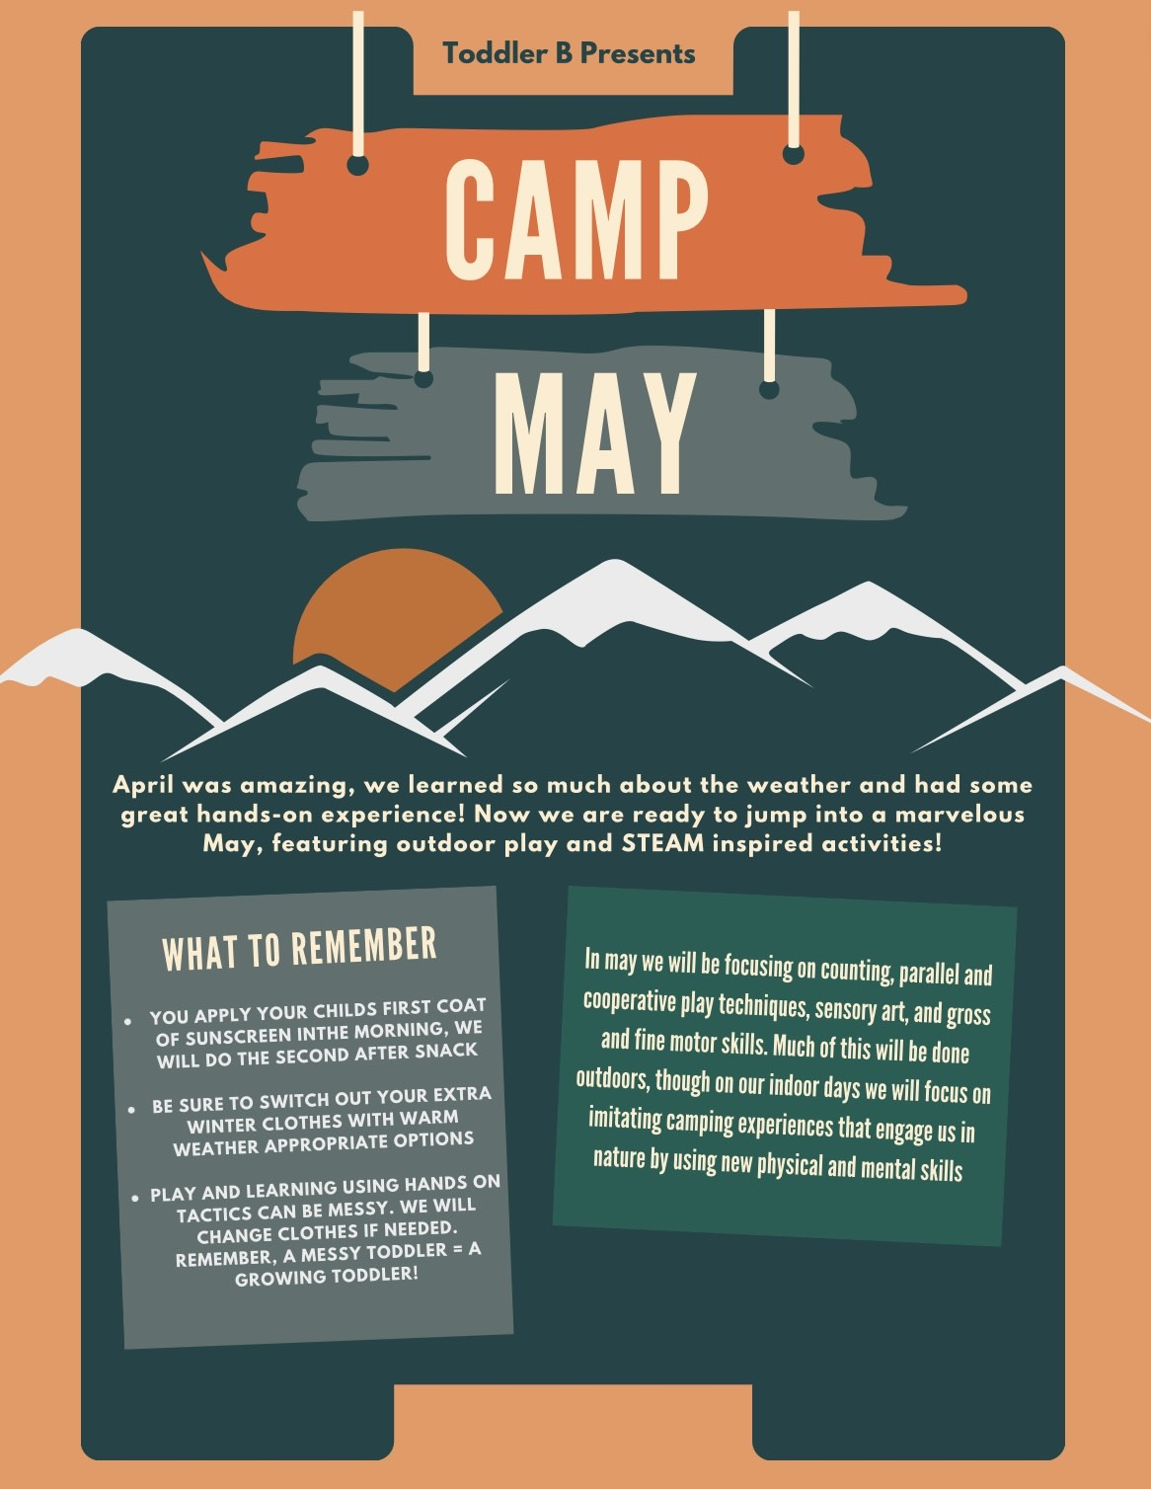

Adventure Awaits (Explorer A)
Hello and Happy May! This month has gone by so fast. We have had fun discussing feelings. Since April had some showers, this May we will be going over flowers! We will be working on recognizing specific flowers (sunflowers, daisies, etc..) as well as learning about the different parts of a flower. Since warmer weather is still approaching, please dress our child accordingly and check their extra clothes bins for warm weather clothes such as t-shirts and shorts.

Reminders:
- As your child gets ready for potty training, it is preferred that pull-ups have the Velcors o the sides. They make it so much easier and faster for us to change multiple children. Please no Pamper 360’s.
- ALL toys must be left at home. It causes arguments between the kids, and we also don’t want the responsibility of them getting lost or broken. A soft lovely is allowed for nap time.
- Please check your child’s cubby every Friday to make sure they have enough spare clothes for the following week that are weather appropriate.
- Please leave spare shoes in your child’s cubby.
- Please bring a jacket daily or leave one in your child’s cubby. We are still in that time of year that the temperature/weather can change rather fast.
- Fridays are Show and Tell day. You may bring in a soft toy to share with the class during morning circle.

You may have noticed that the room has been rearranged and has new centers. We will be working on our listening skills throughout the month to help the children gets used to the new centers in the room. Some of the children’s April favorites have been The Goldfish Song by The Laurie Berkner Band, bunnies (as well as the Sleeping Bunny song) and the Ocean Pop book. We look forward to this month’s events!
Underwater Explorers (Explorer B)
Welcome May! Hopefully we will not have as many “showers” as we did in April! We just want to thank ALL the parents for the hard work you did during the cleanup day. Everything looks fantastic. This month we will be working on our Listening ears 👂 Acting out rhymes, playing red light, green light. As well as working on pincer and large motor skills. You can help by letting your little ones use kid friendly tweezers or tongs and pick up items such as cotton balls, paper balls etc.
Things to remember:
- Please sunscreen before coming to school, we will reapply for the afternoon
- Fill water bottles before or upon arriving to school
- There are A LOT of things going on in May so just watch your emails, brightwheel or however you receive your information.
Ms. Lisa will be out Friday May 26. If you are in town and at the Point Mallard Hot Air Balloons, come by and say hi and get your picture made in the basket. I work with the Balloon that advertises Window World.
Have a Great month!

The Marvelous Monsters (Pre-C)
The children had so much fun and were so proud of their flowers planted on the playground. We have decided to continue their interests in flowers and pollenating insects for our study theme this month. They will study about different varieties of flowers, their functions, and the importance of what both the flower and insects do to produce seeds. We are excited about planting more flowers in our front bed to add to our butterfly bush. We are looking forward to making our flower bed attracting for all of us to observe. We will be having out Mother’s Day Celebration on Friday, May 12th at 2:45. Hope to see you there! Please check to make sure your child has weather appropriate clothing and sunscreen. Thank you all for your continued support.

Wild About Pre-B (Pre-B)
Theme: Flowers
Important Dates:
- May 10th -Mother’s Day Store
- May 10th-12th-Campus Candids with Spoiled Rotten Photography
- May 12th-Muffins for Mom
- May 15th-19th-Staff Appreciation Week
- May 18th-Pre-A Graduation
- May 29th-Center Closed for Memorial Day
Reminders:
- Bring your child’s water bottle daily and please make sure it is filled up with water each day.
Supply requests:
- Storage Tubs all sizes
- Puzzles
Self-Help Content (Wiping Self)
- Teach child how to wipe-show how to hold the wipe flat in their hand and not wadded in a ball. Wipe, fold, wipe, fold, wipe until they don’t see anything on the wipe. Practice makes perfect.
Child Interview
- Tell me what you know about rainbows? Child A said, “Sun and water together makes a rainbow.”
Kindness Corner
- Child A was upset about not bringing a scooter. Child B said, “you can have my scooter and I’ll ride your bike.”

Children Around the World (Pre-A)
Hello from Pre-A! It’s May!!! Flowers will finally in bloom! Our class will study all about Flowers this month! We are all excited!!!
Letters of the month: F S L N
Friendly Reminders:
- Refill water bottle everyday
- Update Doctor’s note/ medicine form
- Send in sunscreen for your child
Important Events:
- May 12th Muffins for Mom, and Mother’s Day Party
- May 18th Graduation Day

