Marshall Child Development Center
February Newsletter 2023
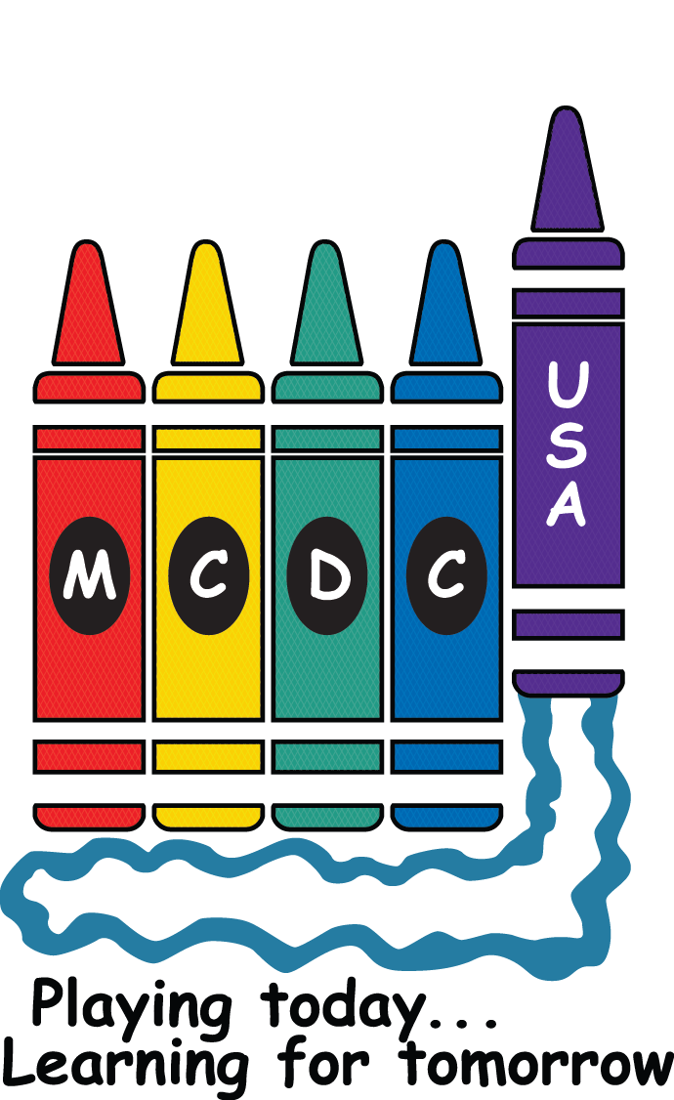

From the Director….!
Welcome February! The month of LOVE!

February Happy Cart:
Please sign up below if you can contribute $10 towards our February Happy Cart to show our love to our teachers!! Be sure to choose family or friend so we don’t get charged a fee. 😊

https://www.signupgenius.com/go/30E0B4DADAD23A75-february1

This is the time of year that registrations start for Pre-K programs in the school systems. Did you know that MCDC’s Preschool A classroom is a top-notch Pre-K?? Some things to consider before enrolling your child in an outside Pre-K program.
Pros:
- If you have an older sibling enrolled at the same school, it is convenient to have both children at the same location.
- Some Pre-K programs are less expensive per week.
- Some Pre-K programs have smaller group sizes
Cons (or things to consider):
- Pre-K programs in the school system do not run year-round. You would have to find care for school holidays and summer.
- Pre-K programs in the school system are not full day. You would have to pay additional for after school care where your child would be mixed with older children.
- Most Pre-K programs are in elementary schools. You child may be with older children at different times of day.
- Lunch would have to be purchased or packed each day

We would love for all our children to stay with us through Pre-K until they enter Kindergarten. Not to keep the center full, but I wholeheartedly feel like our program is more developmentally appropriate for 4/5 year old’s. However, if you do decide to put your child in another Pre-K program, we will absolutely respect your decision, but will cry a little (really a lot) when you leave. 😊

Scholastic Book Fair:
We are so excited for our Scholastic Book Fair taking place February 27th-March 3rd. The book fair will be set up in the cafeteria. More details will come; however, you will be able to set up an account for your child, you can send cash, or you will be able to pay with a card.
There will be bins set up for each classroom with books you can purchase specifically for your child’s classroom.
We use the proceeds from the Scholastic Book Fair to purchase materials for the classrooms. Happy Reading!

Upcoming Events:
February 3rd= Board Meeting 9am
February 7th= Kelli in late
February 9th= Kelli and Cecilia out of the office 12:00pm-3:00pm
February 15th= Kelli and Cecilia out of the office 8:30am-11:30am
February 16th= Staff Meeting 5:45pm
February 17th= Board Meeting 9am
February 18th= Appelbaum Training for Staff in Nashville 8am-3pm
February 20th= Center Closed for President’s Day
February 27th-28th= Scholastic Book Fair
February 28th= Kelli in late

Coming Up in March:
Scholastic Book Fair 1st-3rd
Green Eggs and Ham Breakfast 2nd
Board Meetings 3rd, 17th, 31st
UCP Staff Training 4th
Cecilia & Kelli out of the office 12:00pm-3:00pm 9th
Cecilia out of the office 10th
Kelli out of the office 13th-17th
Staff Meeting 23rd
Cecilia out of the office 27th-31st

Hello from (Infant A)
Hello from Infant A!
Can’t believe we are already in February, the second month of the year! It’s still cold and hot so please make sure you are bringing the prefect clothes for your infant! Remember, we will be closed February 20th for Presidents Day. I hope everyone enjoys this wonderful month.

The Beautiful Babies (Infant B)
Greetings from Infant B Beautiful babies!
Observe babies closely as the interact with their environment. Babies will let you know their interests and abilities by responding to their interests and abilities. You are creating a healthy and challenging environment that promotes babies physical, mental, social, and emotional growth. Also remember babies do need a little time to themselves. When we watch the cues of babies you will learn what interests them as well as things that don’t. Have a great month allowing baby to lead in what interests them.

Farmtastic (Creeper A)
Greetings from the sweeties in Creeper A! We are sharing our theme for February today. For the month of February, we will look at ourselves, hands, and feet. We will sing songs using fingerplays and puppets for the new little ones we meet. We will do artwork where we use paint and pen. Once we’ve made a mess, we’ll do it all over again. Please remember to check your child’s classroom app to see if there are any assignments for you. Then ask us teachers about the things we need you to do.
Reminders:
- Please remember to label all your child’s belongings. Also, remember to sign in and out daily on the App.
Up-Coming Events:
- Feb. 20 – Closed for President’s Day
- Feb. 27 – March 3 – Scholastic Bookfair

The Little Owls (Creeper B)
Hello from the little owls! For the month of February, we are going to be exploring dinosaurs! We will discover what they look like, what they eat, what they sound like, and where they live. We would like to say goodbye to a little owl as they leave the nest to join toddlers. We will miss you! February is going to be a rawr… I mean a hoot.
Reminders:
- Have a change of weather appropriate clothes in the child’s cubby.
- As the weather starts to warm up, we are going to go outside more. Please bring sunscreen we can keep in the classroom.
- Your child loves to see you! Please bring in a family photo for our family tree!

The Busy Bees (Toddler A)
Happy February, Toddler A Family! We are going to be exploring weather this month! We will be focusing on sunshine, rain, snow, and wind.
We are always working on new skills! We have been practicing how to put one arm into our jackets! Independence is the name of the game in toddlers!
We will be having a Friendship party on February 10th at 2:45. Look out for the snack sign-up sheet!
- Please make sure to check your child’s cubby for weather appropriate clothes.
- Feel free to bring in books to share during circle time. Our toddlers love having new books!
- We are always practicing our manners! We work hard on saying “please”, “more”, and “thank you.”
Important Dates:
- February 10th – Friendship Party
- February 20th - MCDC closed for President’s Day
- February 27th-March 3rd – Scholastic Book Fair

Clever Foxes (Toddler B)
Hey there Toddler B families! Just to recap the start to our wonderful year, our tot’s got to read about and try new experiences.
Reminders for parents:
- The weather may be temperamental, but make sure your little one has a warm coat on standby!
- Check out our “What’s Happening in Huntsville?” board for activities around town and ideas for at home fun!
- We LOVE parent participation, if you have a book your child loves, bring it in!
Our next topic is going to be focusing on nutrition! We will be exploring a range of different flavors, discuss different mealtimes, and how to use our utensils by practicing fine motor skills!

Adventure Awaits (Explorer A)
Hello! First, I’d like to welcome Mrs. Bryanna to our classroom. We are excited to have her join us. Where did January go? As we begin February, we will be talking about our 5 senses: taste, smell, sight, hearing, and touch. We will taste things that are salty, sweet, sour, and even bitter. Some we will like and some not so much. We will smell things that are nice and some that are not so nice. We will look at different colors and shapes with our little eyes. We will listen for sounds that we don’t normally hear in class. Lastly, we will touch and feel different textures. We will have a friendship party around February 14th, more details to come with the exact date.

Friendly reminders:
- Please leave all toys at home (it causes arguments between the children). We also don’t want them getting lost or broken. A soft lovey is allowed for nap time.
- Please check your child’s cubby every Friday to make sure they have enough spare clothes for the following week that are weather appropriate.
- Please leave spare shoes in your child’s cubby
- Please bring a jacket daily or leave one in your child’s cubby. Hats and gloves are also a huge plus especially since the wind can make it feel colder than it is.

Underwater Explorers (Explorer B)

Welcome February, the month of friendship! We had to send off a few friends to Pre-C, but good news is we are making new friends from the toddlers. We are going to focus on shapes this month (circle, heart, triangle, and square). If you have favorite shape books or ideas/songs to share, please do! We will be making and finding shapes throughout the room. Our friendship party will be on February 14th at 2:45 with a “love” book exchange. Some ideas for books are “I Love You Because You’re You” and “Lots Of Love Clifford”. We are closed on Monday, February 20th for Presidents Day. The Scholastic Book Fair will be February 27-March 3. February is also National Children’s Health Month. Please check with us if you think you need a new toothbrush. Also, please don’t forget to change your toothbrush out at home.

The Marvelous Monsters (Pre-C)
We had so much fun with our January activities. February is very exciting and a fun month as it brings Valentine’s Day. Our theme for the month is Community Helpers. Also, did you know that February is Dental Health Month? We will be learning about how to have healthy teeth. We will also focus on small group play and positives interactions with others. The Letters for this month are: Ss, Tt, Uu, and Vv.
We would like to welcome our new friends and their families to Pre-C. They are adjusting to their new class very well.
You will be seeing a lot of red, white, pink, and purple throughout this month. We will be celebrating our Friendship party on February 14. The children will exchange Valentines that day during morning circle time and we will have a healthy snack that afternoon @ 2:45. All parents are welcome to attend but not necessarily expected. A sign-up sheet for the food and a list of the kid’s names will be posted in bright wheel a week before Valentines. We hope everyone has a joyful and healthy February!

Wild About Pre-B (Pre-B)
February Theme: All About Me
March Theme: Pond Life
Important Dates:
- February 14 – Friendship Party
- February 20 – Center Closed
- February 27- March 3 Scholastic Book Fair
News:
We are doing Family style dining at lunch. The children are pouring their milk from a pitcher, and they are scooping out their food and putting it on their plates. The children are all doing an amazing job.
Reminders/Notes:
- Nap mats need to go home every Friday, be washed, and be brought back on Monday.
- We are still looking for old suitcases and paper maps.
- A medical authorization form needs to be filled out each week or we must have a doctor’s note on file before your child can have toothpaste or sunscreen.
February Family Activity:
February is National Bird Feeding Month. Take a day to set out bird seed in your yard. You can also make a bird feeder using a pinecone.
February Fun Fact:
Feast of Saint Valentine was started by Pope Gelasius I in AD 496. It was celebrated on February 14 honoring Valentine of Rome who died on February 14 AD 269 and became a martyred saint. It wasn’t until the 14th century when it became associated with romantic love.

Children Around the World (Pre-A)
It’s February! Love is in the air for Preschool A! (Children Around the World) Our class will be studying about Friends! Focusing on being kind, gentle, respectful, and mindful of our words and action towards our friends.
Book: Good Deeds
Activities: Pasta stringing for sensory work preparing little fingers for steadiness in holding pencils.
Friendly Reminders:
- Check brightwheel for important messages or folder above your child’s cubby.
- Check your child’s clothes box every Friday for weather appropriate clothes.
Important Date:
- February 10th - Class Friendship Party! … please watch out for the signup sheet at the door on what to bring
- Center Closed February 20th for President’s Day
- February 14th - Valentine’s Day!
- February 27- March 3 Scholastic Book Fair

Staff Highlights!!
Explorer Teachers


Gina Carver, Explorer A

Years at MCDC: 5 months

Favorite Things About Working in Childcare:
When you have been working on a certain thing and you see the light bulb click when they finally get it!

Interesting Facts:
My hobbies are horseback riding, going to concerts and reading a good book!

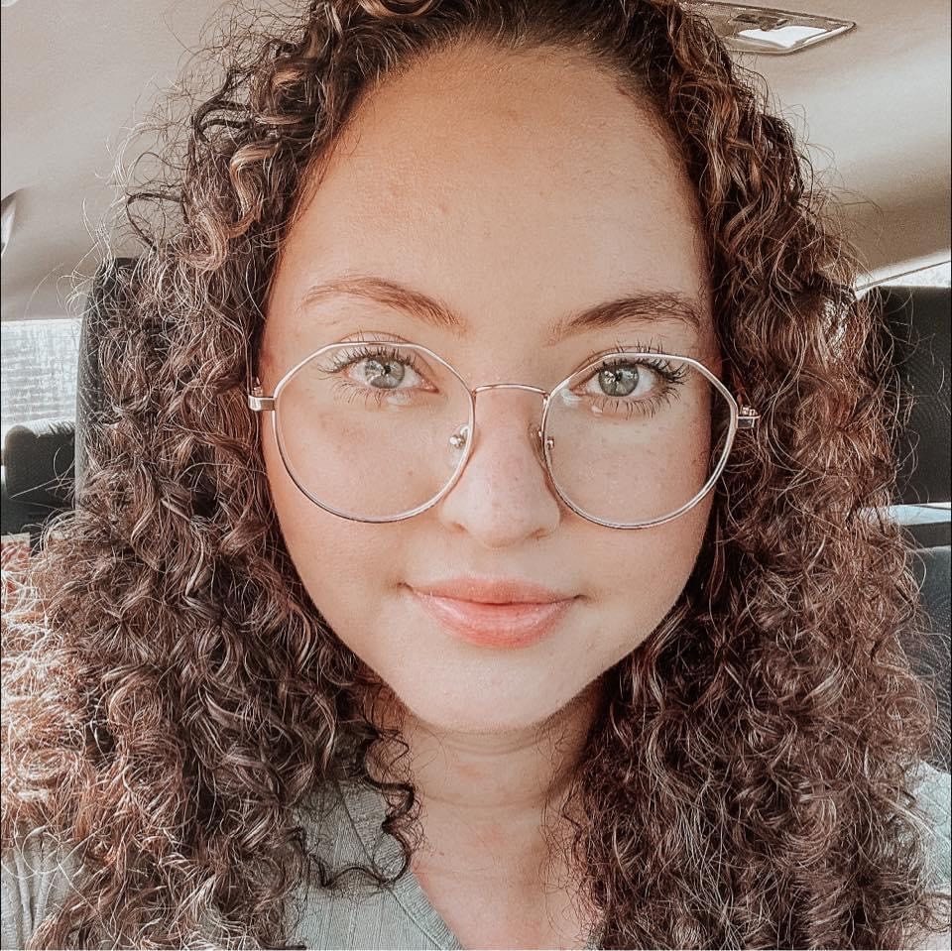
Bryanna Williams, Explorer A

Years at MCDC: 2 weeks

Favorite Thing About Working in Childcare:
Watching personalities develop and seeing your hard work in the children!

Interesting Facts:
I am from West Virgina. I play 3 instruments and enjoy painting and drawing. I love to teach kids sign language. My favorite thing to do is play video games and take naps with my 2 fur babies!

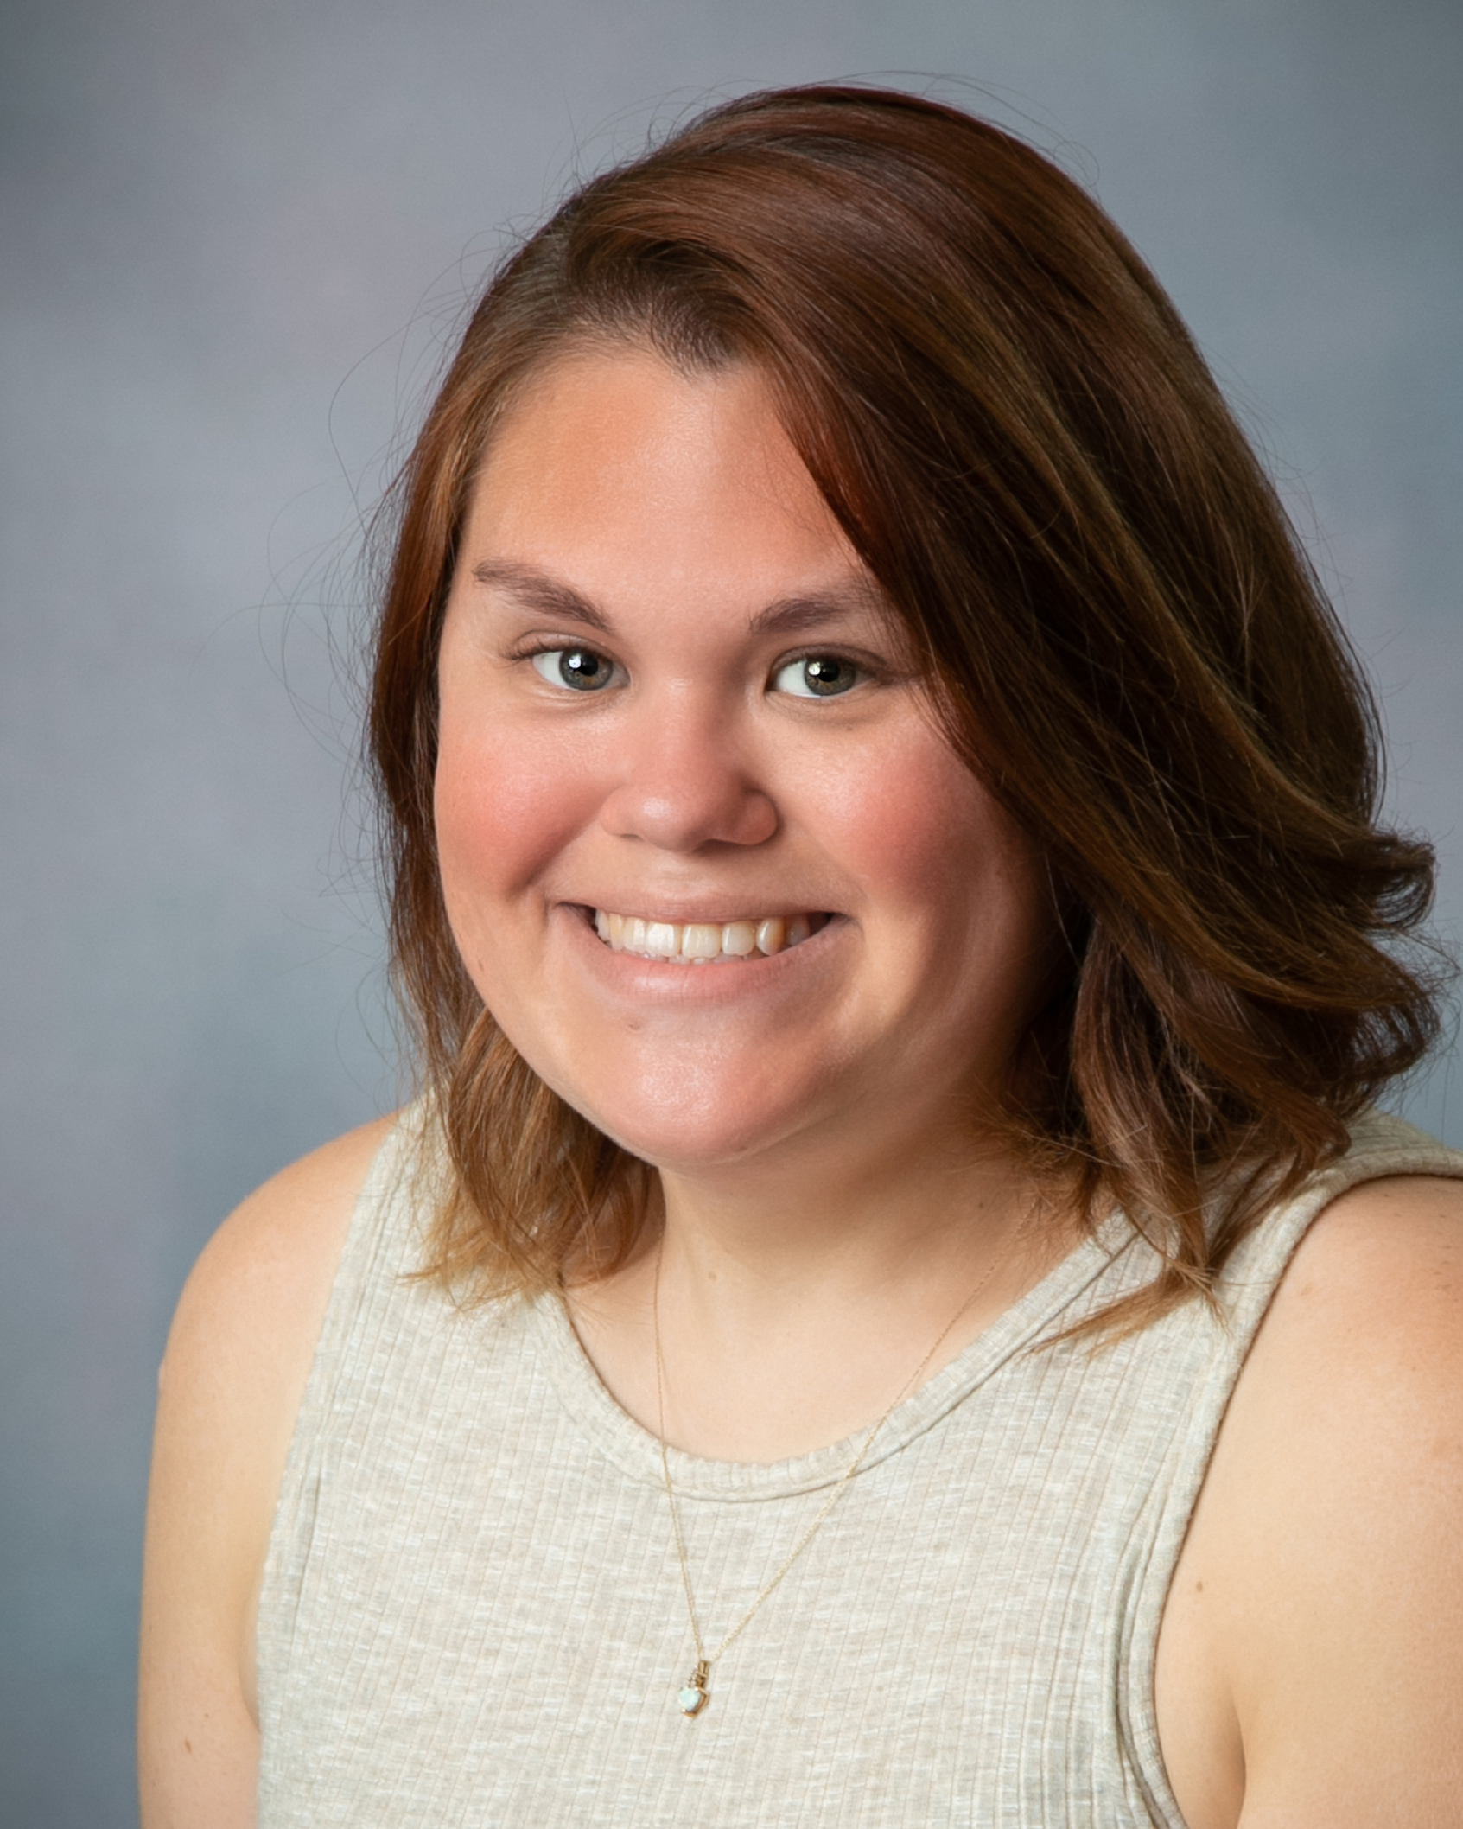
Cassidy Thomas; Explorer B

Years at MCDC: 8 years

Favorite Things About Working in Childcare:
Teaching the kids new stuff every day. They are always making me laugh about stuff.

Interesting Facts:
I love swimming during the summer as well as fishing and hunting. I like singing, just not in front of people. I love hanging out with my husbands family.

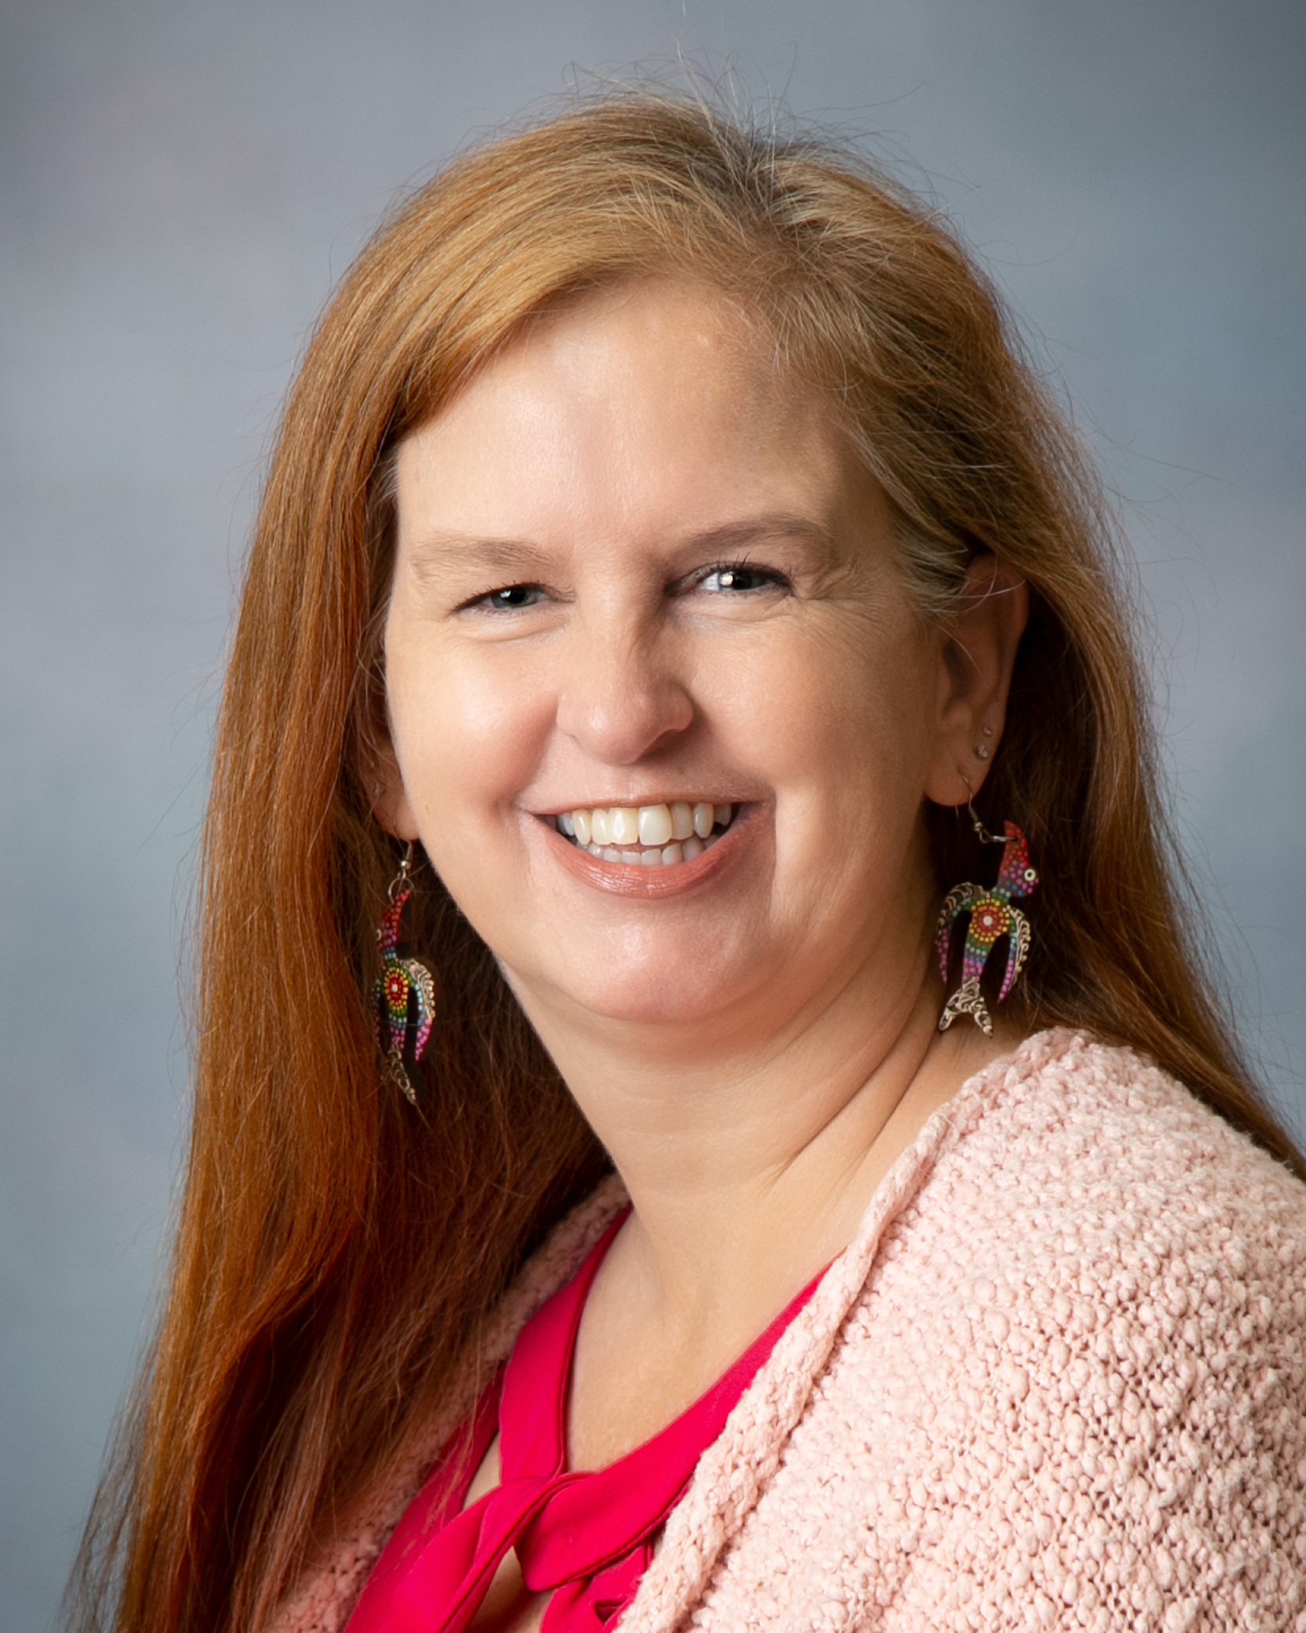
Lisa Bradford; Explorer B

Years at MCDC: 21 years

Favorite Things About Working in Childcare:
I love getting my big 2 arm hugs in the mornings and seeing those smiles. When things are going rough, they always know when you need a hug!

Interesting Facts:
I crew for a friend’s hot air balloon. I enjoy hiking, biking, and traveling. I have 1 daughter graduating in May. I’ll do anything outside to avoid housework! Ha-ha!

