Marshall Child Development Center
April Newsletter 2022
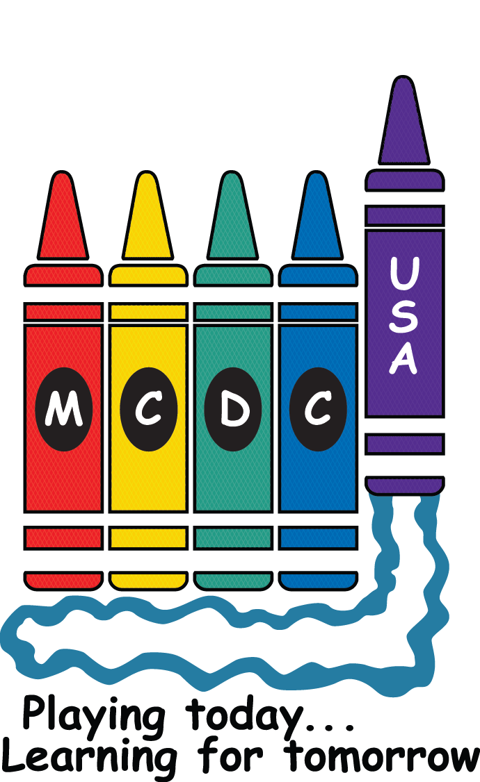

From the Board of Directors…!

It’s almost time for our annual Board elections. New Board members will take office on June 1, 2022. Positions up for election this year are:

- President (must be a MSFC civil servant) – 2 year term
- Secretary – 2 year term
- Registrar (must be a MSFC civil servant) – 2 year term
- Member-at-Large, representing enrolled families – 1 year term
- Member-at-Large, representing wait-list families – 1 year term

We do hope you will all give serious consideration to running for a position. MCDC is a non-profit, parent-run entity. We are not part of the Exchange or a formal part of the MSFC institution. As such, MCDC is shaped by the families that are members. Serving on the board is a way to give back to the place that will play a key role in the lives of your children.

Be on the lookout for an email in the next few weeks calling for nominations. Please contact any of the board members if you have questions about our roles.

For a list of responsibilities see our website at:
https://mcdc.msfc.nasa.gov/business/current_board
or our bylaws:
https://mcdc.msfc.nasa.gov/business/bylaws

From the Director….!

Thank you, thank you, thank you to those who were able to contribute to the March Happy Cart!! Our staff were certainly happy when we wheeled the treats around! Look at that spread!

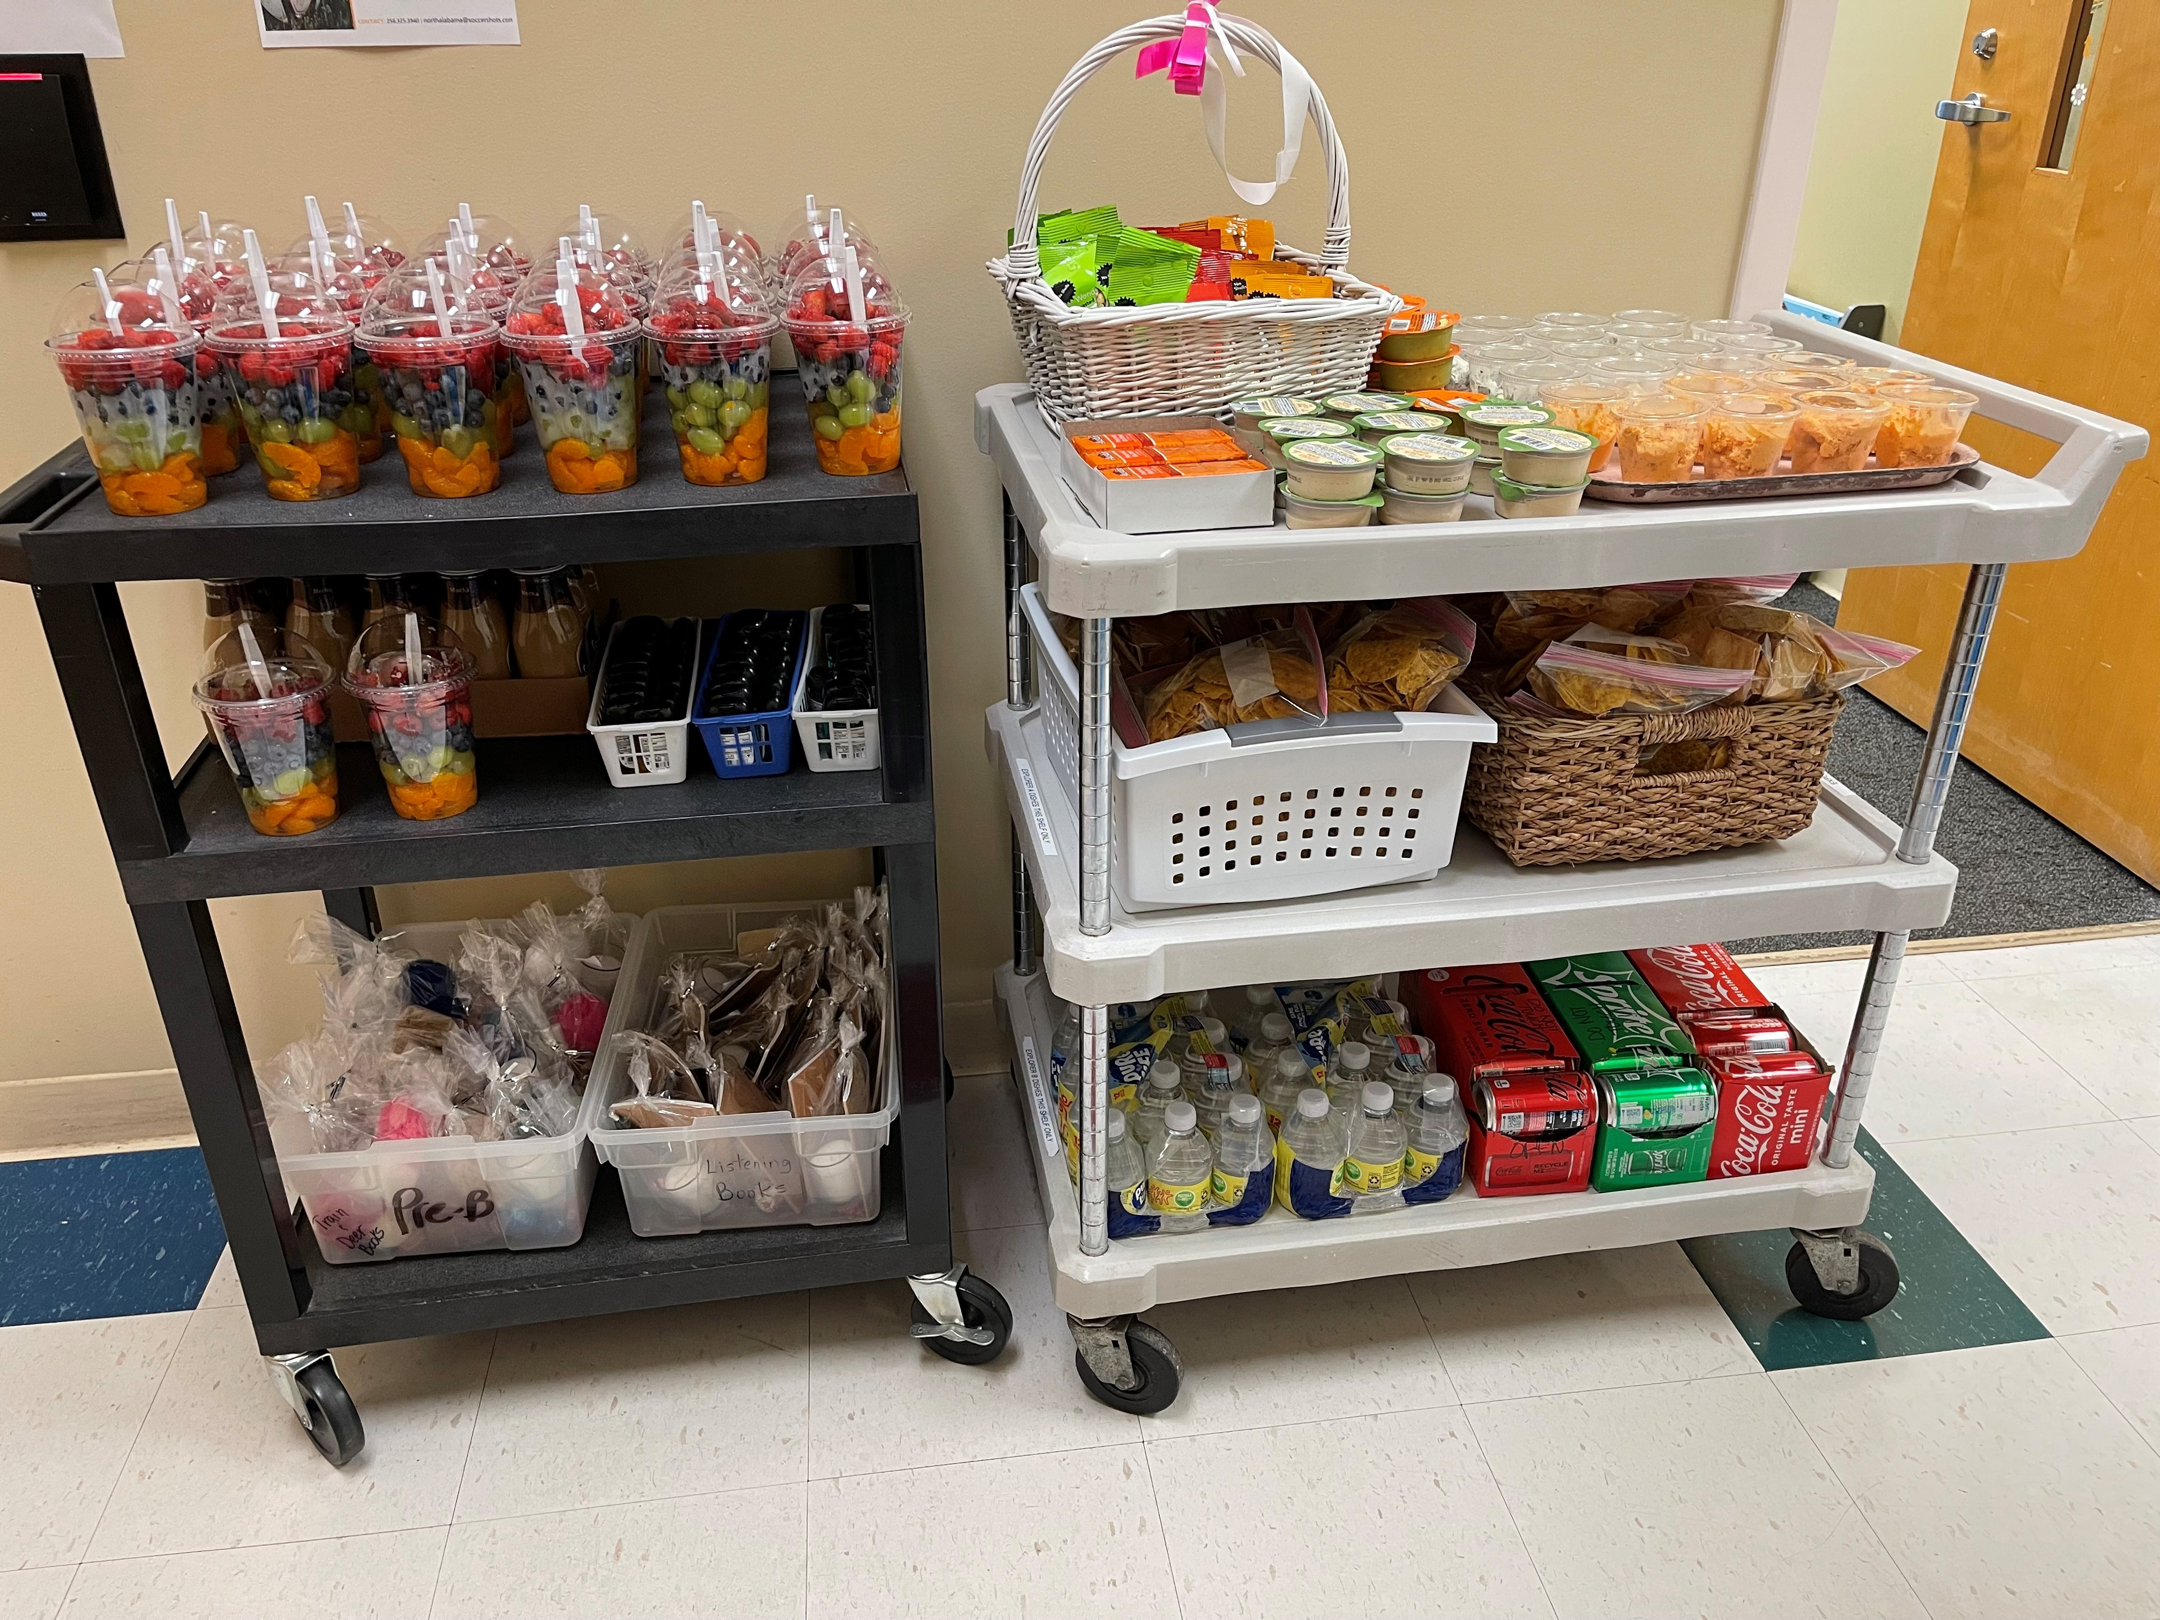

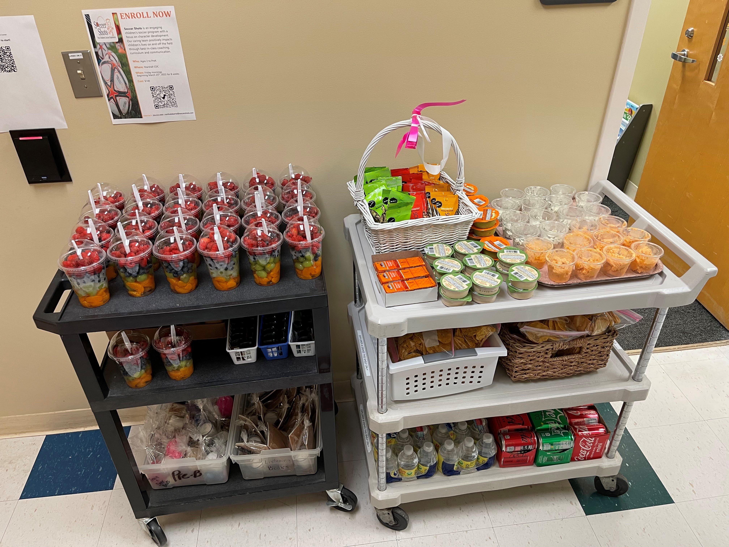

Our Scholastic Book Fair was a huge success!! We were able to purchase $1033.91 worth of supplies/activities for some classrooms and our Multi-purpose Room! All while promoting literacy!! Win, win!!

MCDC Annual Egg Hunt
We are so excited to have our egg hunt this year on Friday April 15th!! All the egg hunts will take place on the children’s playgrounds.

Creepers will hunt at 2:45pm, Toddlers and Explorers will hunt at 3:00pm and Preschool will hunt at 3:15pm.

Family and friends are welcome to join us! (please use medical center parking lot for overflow parking; parking on the curbs and grass is prohibited)

We do need your help to make our egg hunt the best one yet. We will be taking donations of pre-filled eggs (preferred) or plastic eggs and candy. All candy must be individually wrapped. All candy must be nut free and not processed in a facility that processes nuts. Also keep in mind that the candy must be able to fit in the plastic eggs. Some suggestions are Hershey kisses, tootsie rolls, and starbursts.

Please bring in any donations by Thursday April 14th.

Week of the Young Child April 18th-22nd
Monday: Creative Art and Music Day
We will spend the day on Monday doing lots of creative art! If you have any art mediums you would like to donate, we would love that! We will also be celebrating all different types of music! If you have a special talent in the music field and would like to share with us, please coordinate with your child’s teacher.
Tuesday: Read Aloud and dress as your favorite book character Day
Bring in your favorite book to share and dress as your favorite book character! We will be reading rock stars on Tuesday.
Wednesday: Trike-A-Thon
Our annual Trike-A-Thon is to benefit St. Jude Children’s Research Hospital. Our goal this year is to raise $5000!! You will find a pledge sheet in your child’s folder or cubby. The pledge sheets need to be turned in by Friday April 22nd. You may also set up a page online for your child to raise funds. Share on your social media platforms! Visit stjude.org/trike click “find your school” and then “register. The classroom that raises the most money will get a Pizza Party!!
The preschool children will bring in a riding toy (tricycle, bike, but nothing electric) and they will ride around the front parking lot. Please plan to have your children dropped off and the parking lot clear by 8:45am that morning. The preschoolers will park their tricycles or bikes in the front of the center by their classroom label. You must have a helmet for your child as well. Please label both trike and helmet.
Preschool C will ride from 9:00am-9:20am, Preschool B will ride from 9:25am-9:45am and Preschool A will ride from 9:50am-10:10am. (*no walking or running allowed)
The younger children may bring in a riding toy to play with on the playground on Thursday. You can take this riding toy directly to your child’s classroom on Thursday when you drop off. Please label your riding toy.
Thursday: Field Day/Picnic Lunch (picnic lunch for toddlers and older)
Today will be spent doing all the fun things outdoors! We would love donations of playground balls, chalk, bubbles, and anything else your children love to do outdoors.
Please join us for a picnic lunch on the playgrounds at 11:00am. You may bring lawn chairs, blankets, etc… Children ages toddler and up will need to bring in a packed lunch with drink. *No peanut products*
Friday: Science Day and Ice Cream Social
We will end the week with a bang! We will be conducting science experiments. If you have any ideas for us, please let your child’s teacher know! We would love to have you come conduct an experiment with us!
We will also have an Ice Cream Social at your child’s snack time. MCDC will provide the ice cream and we will have a sign up for toppings.

We appreciate all the support and participation this week of celebrating our most precious ones!!

Upcoming Events:
April 4th= Petting Zoo
April 14th= Staff Meeting 5:30pm
April 15th= MCDC Egg Hunt
April 18th-22nd= Week of the Young Child
April 26th= Preschool A Cap & Gown Pictures
April 27th-29th= AELL Director’s Conference

Coming Up in May:
Mother’s Day Store (preschool) 4th
Campus Candids with Spoiled Rotten Photography 5th-6th
Board Meetings 5th & 19th
Preschool A Graduation 19th
Center Closed 30th

Hello from (Infant A)
Hello parents of Infant A! Can you believe that spring has sprung?! The flowers are bloomin’, the bees are buzzin’, and the weather is all over the place!
I am beyond thrilled to announce that I will have a new co-teacher joining me on Monday, April 4th! She has been a teacher in Creeper B for many years and will be leaving her room to work with our precious infants. I know she will fall in love with their sweet personalities, just as I have. Additionally, we will have a new infant floater starting on April 4th, as well! Please join me in making them feel welcome to Infant A!
April looks promising to be a fun month with lots of different activities and cute artwork. Lastly, with the temperature change, please make sure your infants spare clothing is weather appropriate!
Thanks!

The Beautiful Babies (Infant B)
Greetings from Infant B’s Beautiful Babies,
We are having the best days ever! Our babies keep things interesting. Physical development refers to gradual gaining of control over large and small muscles. It includes acquiring gross motor skills such as sitting, crawling, walking, running, and throwing and fine motor skills such as holding, pinching, and flexing fingers and toes. Coordinating movement is also an important part of physical development. We use our senses – especially sight, sound, and touch – to coordinate the movement of our large and small muscles.
Young children do not have to be reminded to practice physical skills. Most infants will gleefully kick their legs and reach for objects. Physical development is important for developing self-esteem. Young children use their large and small muscles, along with their senses to discover their world and the effects they can have on it. Have a great month!

Farmtastic (Creeper A)
Welcome Spring and all that it brings!
Hard to believe that we are already into this season and soon it will be warmer. This month we will focus on spring. We will look at the animals of spring, spring rain, rainbows, and bunnies. Lots of time for fun and learning as we play.
Also, one little chick has left the nest as another new one has hatched, and we want to wish a Happy Birthday to all who turn one in April.
Happy April!

Upcoming Events:
- MCDC Egg Hunt – April 15th @ 2:45
Friendly Reminders:
- Label all your child’s belongings
- Make sure that you’re signing your child in and out on both paper and in the app!
The Little Owls (Creeper B)
Hello from Creeper B!
Spring is here! It’s time to cheer! We couldn’t be more excited that Spring has finally sprung – we have so many fun activities planned for this month!
First, a petting zoo will be coming back to MCDC, and our sweet kiddos will be able to take a stroll outside to see and touch the very gentle animals that come. This will take place on April 4th at 9:00, so please make sure your child is in by 8:30 that morning so no one will miss out on the fun!
Also, we will be having our annual Egg Hunt at 2:45 on April the 15th – all parents are invited to come help your child hunt some eggs on the playground this day. It’s always so much fun!
And finally, we will also be having Week of the Young Child this month – we will send more information about this very soon!
For the month of April our theme will be April Showers bring May flowers! We will be learning all about the weather! How the weather can change, how it effects things around us. We hope to watch the rain through the windows and play outside to feel the nice breeze in the air!
We want to wish one of our owls a very HAPPY FIRST BIRTHDAY on the 8th!
April is going to be a HOOT!

Friendly Reminders:
- Please apply sunscreen to your child each morning before dropping off
- Please make sure your child has a doctor’s note for sunscreen so we can reapply it in the afternoons.
- Please make sure to check your child in and out each day

The Busy Bees (Toddler A)
Happy spring Toddler A family!
We will be exploring the wonderful world of farm animals this month!
We will focus on cows, sheep, chickens, and pigs. Feel free to bring in a stuffed animal, toy, or a book to share that goes along with farm animals.

Dates to remember:
- April 15th @ 3pm Toddler Easter Egg Hunt. Details to follow.
Reminders:
- It’s getting to that time of year where we need updated doctor’s note for sunscreen. If you don’t have a current one, you will need to fill out the paperwork we can provide for the application of sunscreen in the afternoons.
- Also, with the weather change, please make sure your child has two changes of WEATHER APPROPRIATE clothes.

If you have any questions or concerns, feel free to contact us through brightwheel!
Thank you!

Clever Foxes (Toddler B)
Classroom News
Greetings from Toddler B! Can you believe it’s already April? We are so excited for spring and all the warm weather that’s ahead! For the month of April, we will be learning about BABY ANIMALS! Such as baby cows, ducks, chicks, bunnies and so much more. We will also be learning new songs and will be doing lots of different art activities we are very excited about.
Events
- Egg Hunt April 15th @3:00 🥚parents are welcome to attend
- Earth Day is April 22nd 🌎
Reminders
- Please sign your child in and out at the kiosk located at Melissa’s desk when you come In.
- Please check your child’s cubby for weather appropriate clothing for the springtime weather
- Also, if you have not brought in a doctor’s note for sunscreen and updated diaper cream, please do so as soon as possible. *please bring sunscreen as well*

Adventure Awaits (Explorer A)
Hello from Adventure Awaits, Explorer A! Spring is here! We are going to explore this April about Toys! It will be a lot of fun exploring and playing different toys and cleaning them up afterwards! 🥰and … we are excited to welcome our new teacher! Welcome to our class!
Reminders:
- Please update doctors note for sunscreen, cream and toothpaste. Wash and refill water bottle each day. Check boxes for weather appropriate clothes Please continue to follow up potty training at home Thank you, dear parents!

Dates to Remember:
- April 4th-Petting Zoo (9:00am)
- April 15th-Egg Hunt (Explorers @ 3:00)

Underwater Explorers (Explorer B)
Hello April! Wow March went by so quickly! Thank you so much to the parents who were able to purchase some new items for our classroom. We are so grateful for your generosity and the children are loving their new activities.

This month we are talking about bugs and springtime.

Upcoming Events:
April 15th- Egg Hunt 3:00pm (on our playground)
April 18-22 is Week of the Young Child.
Monday-Creative Art and Music Day.
Tuesday Read aloud and dress up your favorite character book.
Wednesday-Trike-A-Thon you may bring in a riding toy.
Thursday-Field Day/Picnic Day. Picnic is at 11am.
Friday-Science Day/Ice Cream Social Ice cream social at snack time.

Happy 3rd Birthday to a special boy this month! We look forward to celebrating!

*Don’t forget to take water cups home to clean.

The Marvelous Monsters (Pre-C)
Dear Parents,
First, let us welcome our new students and their families into our classroom. They are adapting very well and seem happy and comfortable. Spring has arrived and we’ve already begun taking advantage of the wonderful weather! Please check to make sure your child has an adequate supply of weather appropriate clothing (including shoes.)
Our study for this month will be: “All Things Spring!” Preschoolers absolutely adore getting into nature. The spring season is perfect for getting those little hands into the dirt, planting some seeds, and learning more about the beauty of weather, sunshine, and the rain. Our focus for this month will be classroom structure and promoting self-esteem! 😊 Our schedule for Week of The Young Child will be posted in the classroom later.
Every morning at 8:30 we have circle time. During this time, we read, sing songs, and discuss about our monthly study as well as many other learning activities. The children learn SO much during this time! With that being said, we kindly ask to have your child to school by 8:30, so they can all be present for this important time of the day.
As always, please let us know if you have any questions or concerns about your child. Thank you for your continued support and encouragement!
Respectfully,
Pre C Teachers

The Superhero’s (Pre-B)
Hello from Pre-B,
Thank you to all the parents who have donated items to the classroom. We are so excited about all of them. The items will help the children have fun with learning! New items are added randomly depending on the needs of the children. Right now, we are focusing on literacy and math.
April provides lots of fun days and opportunities to do things with your child. Check on the fun April days: April 1: April Fool’s Day - April 2: International Children’s Book Day – April 12: International Day of Human Space Flight – April 15: World Creativity Week – April 17: Easter – April 20: Brazilian Carnival – April 22: Earth’s Day – April 23: Shakespeare’s Birthday – April 23: World Book Day - April 27: Pet Day – April 29: Arbor Day
April Quote: Hello, April! Surprise me. Goodbye March. Hello April, Hello April, please don’t fool me.
Theme: Dinosaurs
Important Dates:
- April 4 – MCDC Petting Zoo
- April 15 – MCDC Egg Hunt (Preschool hunts at 3:15)
- Week of the Young Child (more information to come)
Friendly Reminders:
- Please bring your child’s water bottle every day and make sure it is filled up.
- Check on top of your child’s cubby every day. There could be important information or your child’s work.
- Our circle time starts at 8:30. This is a very important time of the day for your child to learn. It’s important that they are here to participate in circle time.
- If you have not brought in a toothbrush and flushable wipes for your child, please do so. Also, I need Medical Authorization Form (weekly) or a Doctor’s Note (yearly) for sunscreen and toothpaste.
- Check your child’s extra clothes bin to make sure they are weather appropriate for the changing season. Also, make sure the clothes or shoes still fit. The children are growing like weeds and quickly outgrow their clothes and shoes.
Thank you!
Pre B Teachers

The Hopping Frogs (Pre-A)
Dear Parents,
The changing of seasons is a magical time. In North America, the months of March and April mark the end of winter and the beginning of spring.
Spring is a time of excitement – the beginning of a whole new growth cycle for the earth after a quiet winter. We are seeing new life and growth, which compels us to find stories and language to share with the children around us. Children learn by active participation and involvement.
The children really enjoyed learning more about “Farm Animals” in March and this month we will learn more about “Weather.” We have completed the alphabet and will start reviewing them starting this month. We will focus on 2 letters a week and we will go in the ABC order as we review. We would really like to do more writing them.
We have one friend who will celebrate her 5-year-old birthday this month! We wish her a very HAPPY BIRTHDAY!!!
The days are going to be warmer, so please check your child’s change of clothes to be sure they are season appropriate.
We are also asking that you bring in new toothbrushes and toothpaste this month too. We will also apply sunscreen in the afternoon as well.
Happy Spring and welcome back to PreK A to a very special family!

Pre A Teachers

