MCDC Board of Directors -- Meeting Agenda

Tuesday, September 29th, 2020

 |  | Present | Absent
President | Vicky Garcia | X
Vice President | Eileen Beardsley | X
Director | Kelli Wright | X
Assistant Director | Cecilia Finn | X
Secretary | Rachel Garces |  | X
Treasurer | John Peugeot | X
Registrar | Yvonne Villegas-Aguilera | X
MAT (wait list) | Tristan Lane | X
MAT (enrolled) | RJ Habig | X
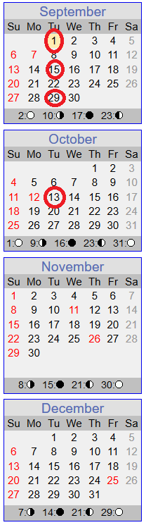
President notes: - Robyn did a good job advertising to Team Redstone
- Director/Assistant Director
  - Updates
    - 73% Enrollment
    - Two internal teachers applied for the opening in Creeper A.
  - Virtual Conference?
    - Went well. Melissa held down the fort for the past few days.
  - Any bites from advertising?
Kelli – Hasn’t heard anything since advertising on Team Redstone. However, 2 families asked more info about drop in care. Question came up about parents using drop in care if they sign the same forms. They must also sign the same paperwork and follow the same policy as everyone else.
- President:
  - Emailed accountant from bank where PPP Loan was obtained for filling out loan forgiveness form. Have not heard back. Vicky will keep pushing and inform the new Board.
- Vice President:
- Treasurer:
  - Status
  - Budget Discussion
    - Enrollment Assumptions?
      - Went over the Profit/Loss Charts – right now, we are about 24k in the red, but if the low enrollment continues, we could be looking at a loss of 80k, possibly up to 140k loss for the year. Still survivable number based on where our savings was previously.
      - Showed enrollment rates min/max from previous years. Need to make realistic enrollment estimate. Difficult to predict due to COVID. Waitlist is still strong but people are waiting till January or February. Big part of it is when we will go back to work. Discussion to work budget starting with historically minimum enrollment. John will send out the spreadsheet to everyone to look over.
    - Plan for replenishing reserve, if any?
  - Budget Planning for 2021 Timeline
Membership vote – Nov. 19-20
Send out to membership – Nov 5-6
Board approval vote – Oct 27th (if I’ve got my weeks correct)
Misc. discussions each meeting from now until 10/27, i.e. assumption of enrollment %, bonus structure, various tuition increase options….
Integrating new Treasurer – starting now with the concept that Heath will present the budget to the board on 10/27, but I will help lead discussions on the various assumptions near term.
- Members at large:
  - Silent Auction for fundraising? (In lieu of Fall festival?) Planning for Week of Nov 16-20th?
    - No updates.
- Secretary:
- Registrar:
  - Updates/Status?
    - 3 infant slots offered, 1 accepted starting Oct 12th.

Future Board Meeting Tentative Agendas

FUTURE TOPICS
- PPP Loan Forgiveness Application (Loan period ends 9/27 –
submit application after loan period but before December)
- Independent Financial Review by CPA
- Review By-Laws

