MCDC Board of Directors -- Meeting Agenda

Wednesday, January 22nd, 2020

 |  | Present | Absent
President | Vicky Garcia | X
Vice President | Eileen Beardsley | X
Director | Kelli Wright | X
Assistant Director | Cecilia Finn | X
Secretary | Rachel Garces |  | X
Treasurer | John Peugeot | X
Registrar | Yvonne Villegas-Aguilera | X
MAT (wait list) | Tristan Lane | X
MAT (enrolled) | RJ Habig |  | X

- Director/Assistant Director
  - Staff (Applebaum training?)
  - End of Year Evaluations
  - Insurance Renewal – Any comments?
  - Belks?
- President:
  - Ideas for getting more Ipad donations?
  - Child Management Software Discussion
  - Bookshelves
- Vice President:
  - Outdoor Classroom Garden Planning (March timeframe?)
- Members at large:
- Treasurer:
- Secretary:
- Registrar:
- Upcoming Events:
Feb 17th – Presidents Day
Feb 18th – Staff Meeting (Eileen?)
Feb 19th – Board Meeting
Feb 22nd – Trunk Show (Tristan)
- Upcoming Topics
  - Board Elections (April timeframe?)
  - Finalize End of Year Bonus Plan
  - Staff Lounge
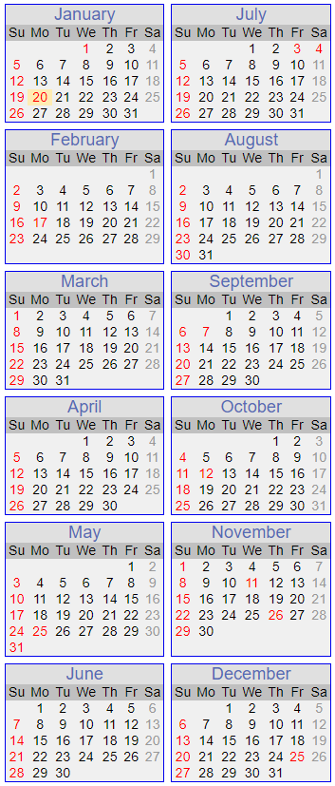
Tentative Yearly Calendar 2020
January
1st Center Closed for New Year
1st- 6th Cecilia out of the office
8th Board Meeting
18th Ed Camp at Randolph
20th Center Closed; MLK Day
21st Staff Meeting 6pm
22nd Board Meeting
23rd Class Pictures
February
1st Appelbaum Training; B’ham 8am-1pm
5th Board Meeting
17th Center Closed for President’s Day
18th Staff Meeting 6pm
19th Board Meeting
29th Appelbaum Training; Nashville 8am-3pm
March
4th Board Meeting
6th Green Eggs and Ham Breakfast 7:45am-8:30am
8th Daylight Savings Time Begins
18th Board Meeting
19th Staff Meeting 6pm
20th Kelli leaving 11am
24th-26th Campus Candids w/Spoiled Rotten Photography
27th Melissa out of the office
30th-31st Cecilia out of the office
April
1st-3rd Cecilia out of the office
1st Board Meeting
8th Pre A Mexican Egg Hunt
9th MCDC Egg Hunt; 2:45pm
11th MCDC Workday 8am-12pm
13th-17th Week of the Young Child
14th Staff Meeting 6pm
15th Board Meeting
16th Trike-A-Thon 9am-11am
17th Cecilia out of the office
23rd-25th AELL Conference; Kelli & Cecilia out of the office
28th Cap & Gown Pictures w/Spoiled Rotten Photography
29th Board Meeting
May
7th Mother’s Day Store
8th Muffins for Mom
11th-15th Staff Appreciation Week
13th Board Meeting
14th MCDC Graduation 5:30pm
15th MCDC Staff Appreciation Dinner 5:00pm; Center Closing at 4:45pm
22nd Kelli leaving at 1:30pm
25th Center Closed; Memorial Day
27th Board Meeting
28th Staff Meeting 6pm
June
1st New Board Members Take Office
5th MCDC Anniversary Picnic 5:30pm-7pm
18th Father’s Day Store
19th Donuts for Dad
30th Staff Meeting 6pm
July
1st Fourth of July Parade 9am
3rd Center Closed for Independence Day
18th MCDC Workday 8am-12pm
30th Staff Meeting 6pm
August
24th-28th International Week
25th Staff Meeting 6pm
September
7th Center Closed; Labor Day
24th Staff Meeting 6pm
October
5th-9th Kelli out of the office
12th Center Closed; Columbus Day
16th Fall Festival 5:30pm-7pm; Mandatory Event
November
1st Daylight Savings Time Ends
7th MCDC Workday 8am-12pm
11th Center Closed; Veteran’s Day
17th Staff Meeting 6pm
19th Thanksgiving Lunch 11am
26th Center Closed; Thanksgiving
December
2nd Holiday Store
4th Staff Holiday Dinner 6:15pm
10th Holiday Program 5:30pm
11th Classroom Holiday Parties
25th Center Closed; Christmas

Board Meeting Notes:

- 7 went to Bham to a training this past weekend and it went well. The training was Applebaum and they do a series of different topics and it was a 5 hour class
- End of year Evaluations – Haven’t started yet, but there is a plan to get it started with priority discussions up front/handled first
- Insurance Renewal is going on – Rates aren’t going up, so we are planning on keeping them.
- Belk – Check is ready to be picked up and Eileen will get it tomorrow
- Cecilia has set up an Amazon wishlist and it can be sent out to the parents and Kelli will remind everyone to use Amazon Smile
  - Kelli had it double checked that it came up when you search for it and it is good
- Cecilia had a suggestion about Echo Dot for each classroom so that they could:
  - Use it to talk to the classrooms instead of calling
  - Also use it to play music since they replace CD players often
  - They can also use them to listen into the classroom when you observe
  - Also use them for setting timers for transitions between centers
  - Will add these to the wishlist
- iPad donations – We are still looking at how to get some since we need 11 for the software
- Child Management Software
  - ProCare/Bright Wheel
    - Thoughts on using a Hot Spot and using cellular data
    - Brightwheel has Cyber Security insurance
  - It will be around $6000/yr for using the software and we need to educate the parents on this to get their buy in
    - We can also look into our accountant to see if their costs will go down, since some of the accounting work will be handled by the software
  - We can do a trial run of this but we would need (~2-3) ipads before we do the trial run
- We need to get a volunteer to go to some local businesses to see if they would help with the iPads (use the letter from the Silent Auction)
- The Bookshelves – Cecilia said the company (in Athens) sometimes will run a BOGO deal and we can maybe get the bookcases taken care of this way. We want them all to match
- SGK Fundraiser is 2/21 in the Library and Tristan will send out information to Kelli so it can be sent to the parents
- Also, looking into another fundraising option with 306BBQ
- Budget Report – March 4th
- There will be 3 openings in infant in the next month
  - 3 openings in infant
    - 28 want in between now and August

