MCDC Board of Directors -- Meeting Agenda

Wednesday, January 22nd, 2020

 |  | Present | Absent
President | Vicky Garcia
Vice President | Eileen Beardsley
Director | Kelli Wright
Assistant Director | Cecilia Finn
Secretary | Rachel Garces
Treasurer | John Peugeot
Registrar | Yvonne Villegas-Aguilera
MAT (wait list) | Tristan Lane
MAT (enrolled) | RJ Habig

- Director/Assistant Director
  - Staff Meeting Notes – Training?
  - End of Year Evaluations
  - Any responses to survey?
  - Belks?
- President:
  - IPads handover – 1st week February
- Vice President:
- Members at large:
  - Planning for 2020
    - Work Days – Saturdays or use Flex Fridays? Child Care provided?
    - Outdoor garden planting
    - Field Trips – Cook Museum in Spring (RJ)?
    - Silent Auction for the next Fall Festival
- Treasurer:
- Secretary:
- Registrar:
- Upcoming Events:
Feb 5th – Board Meeting
Feb 17th – Presidents Day
Feb 18th – Staff Meeting
Feb 19th – Board Meeting
- Upcoming Topics
  - Child Management Software (2/5 Meeting)

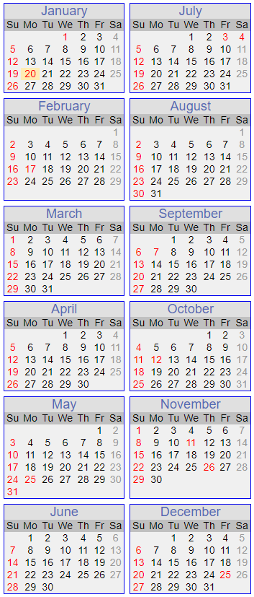
Tentative Yearly Calendar 2020
January
1st Center Closed for New Year
1st- 6th Cecilia out of the office
8th Board Meeting
18th Ed Camp at Randolph
20th Center Closed; MLK Day
21st Staff Meeting 6pm
22nd Board Meeting
23rd Class Pictures
February
1st Appelbaum Training; B’ham 8am-1pm
5th Board Meeting
17th Center Closed for President’s Day
18th Staff Meeting 6pm
19th Board Meeting
29th Appelbaum Training; Nashville 8am-3pm
March
4th Board Meeting
6th Green Eggs and Ham Breakfast 7:45am-8:30am
8th Daylight Savings Time Begins
18th Board Meeting
19th Staff Meeting 6pm
20th Kelli leaving 11am
24th-26th Campus Candids w/Spoiled Rotten Photography
27th Melissa out of the office
30th-31st Cecilia out of the office
April
1st-3rd Cecilia out of the office
1st Board Meeting
8th Pre A Mexican Egg Hunt
9th MCDC Egg Hunt; 2:45pm
11th MCDC Workday 8am-12pm
13th-17th Week of the Young Child
14th Staff Meeting 6pm
15th Board Meeting
16th Trike-A-Thon 9am-11am
17th Cecilia out of the office
23rd-25th AELL Conference; Kelli & Cecilia out of the office
28th Cap & Gown Pictures w/Spoiled Rotten Photography
29th Board Meeting
May
7th Mother’s Day Store
8th Muffins for Mom
11th-15th Staff Appreciation Week
13th Board Meeting
14th MCDC Graduation 5:30pm
15th MCDC Staff Appreciation Dinner 5:00pm; Center Closing at 4:45pm
22nd Kelli leaving at 1:30pm
25th Center Closed; Memorial Day
27th Board Meeting
28th Staff Meeting 6pm
June
1st New Board Members Take Office
5th MCDC Anniversary Picnic 5:30pm-7pm
18th Father’s Day Store
19th Donuts for Dad
30th Staff Meeting 6pm
July
1st Fourth of July Parade 9am
3rd Center Closed for Independence Day
18th MCDC Workday 8am-12pm
30th Staff Meeting 6pm
August
24th-28th International Week
25th Staff Meeting 6pm
September
7th Center Closed; Labor Day
24th Staff Meeting 6pm
October
5th-9th Kelli out of the office
12th Center Closed; Columbus Day
16th Fall Festival 5:30pm-7pm; Mandatory Event
November
1st Daylight Savings Time Ends
7th MCDC Workday 8am-12pm
11th Center Closed; Veteran’s Day
17th Staff Meeting 6pm
19th Thanksgiving Lunch 11am
26th Center Closed; Thanksgiving
December
2nd Holiday Store
4th Staff Holiday Dinner 6:15pm
10th Holiday Program 5:30pm
11th Classroom Holiday Parties
25th Center Closed; Christmas

Meeting Notes (Tristan in for Rachel):

Staff Meeting was held 1/21 and email was discussed that was received from Randolph after the training class (18 MCDC employees went). The email was in regard to some negative comments that were made by MCDC staff and overheard by Randolph training organizers. Kelli reminded the staff that they are to always be cognizant of representing MCDC in the best light no matter where they are.

Kelli discussed the employee evaluation process and how things are to be handled if there are every any consequences and need for follow up. Kelli/Cecilia will set up time next week for the staff members’ evaluations. Parent surveys are also mentioned to the staff as part of the evaluations.

Vicky will be sending out Kelli’s evaluations to the board.

For the Kindergarten/former MCDC kids survey, Kelli has received 11 so far and will plan to discuss the results/feedback with the board later.

Heard back from Belk in the middle of the Board Meeting and our “portion” of the Charity Sale workday is at the Bridge Street customer service desk. Someone needs to go and pick it up but we didn’t mention in the meeting who would go – TBD. We also don’t know the total yet either.
- The money from the ticket sales we collected before the Charity Sale were placed in the expense account under the “fundraiser tab”
  - We think there is around $900 in there total

We will be having an Air Force student come and intern here for several months as part of some training completion for her degree. We will not have to pay for her internship.
- Kelli will let the staff and parents know

We will have another intern (college student) coming in to observe.
- Kelli will let the staff and parents know

For the Child Management Software (will be discussed in more detail at Feb 5th Board Meeting)
- We will need 11 iPads
- We now have 6 Fire Tables for the Preschool kids to use
- No kids will be using the iPads (once we get them)
- We discussed fundraising tactics/donations for them
  - Kelli said she would work with Pam Bourque [legal] on if we can reach out to any companies that have contracts with NASA
- They are around $250 each

More fundraising topics
- We still need 24 BookShelves (~$200 each)
  - Creeper – 4
  - Toddler A – 8
  - Toddler B – 5
  - Explorer B – 7
- Tristan will have the Spring Shrimp & Grits Kids Trunk Show on Feb 22 in the library
  - All commission she makes will be donated to MCDC
- We will plan to start working donations for the MCDC Fall Festival this spring (March)

Cleaning Supplies savings are still going well

Kelli will check with Amazon smile on making sure the “link to MCDC” is working since some people are having trouble finding it

Field Trip Planning:

RJ has worked with the Cook Museum (see information in email)
- Kids are $10 each
- Teachers are free
- Parents are $17
- Busses will run around $400
- We would tell the parents that they will need to back lunch for the kids instead of trying to get the food there (would be chaotic)
- We are working on date for this still and we have $1000 in the budget for field trips, so hoping we can do this one and then the pumpkin patch too

Outdoor Garden:

Eileen said she would be in charge of it and will work with the teachers at the next staff meeting (Feb 18th) to see what they would like to plant. She said they could start that in March and not wait until the first scheduled work day, which is in April.

Waiting List:
We have 3 infants coming in soon

Book Fair is coming up from Scholastic and we need to tell the parents that depending on the book sales we can get “Scholastic Dollars” that can be spent on things other than books, such as electronics

April AELL conference was mentioned to Staff at the Jan staff meeting and Kelli will send out notes on it

We will talk bonuses at the next board meeting.

